**What's on:**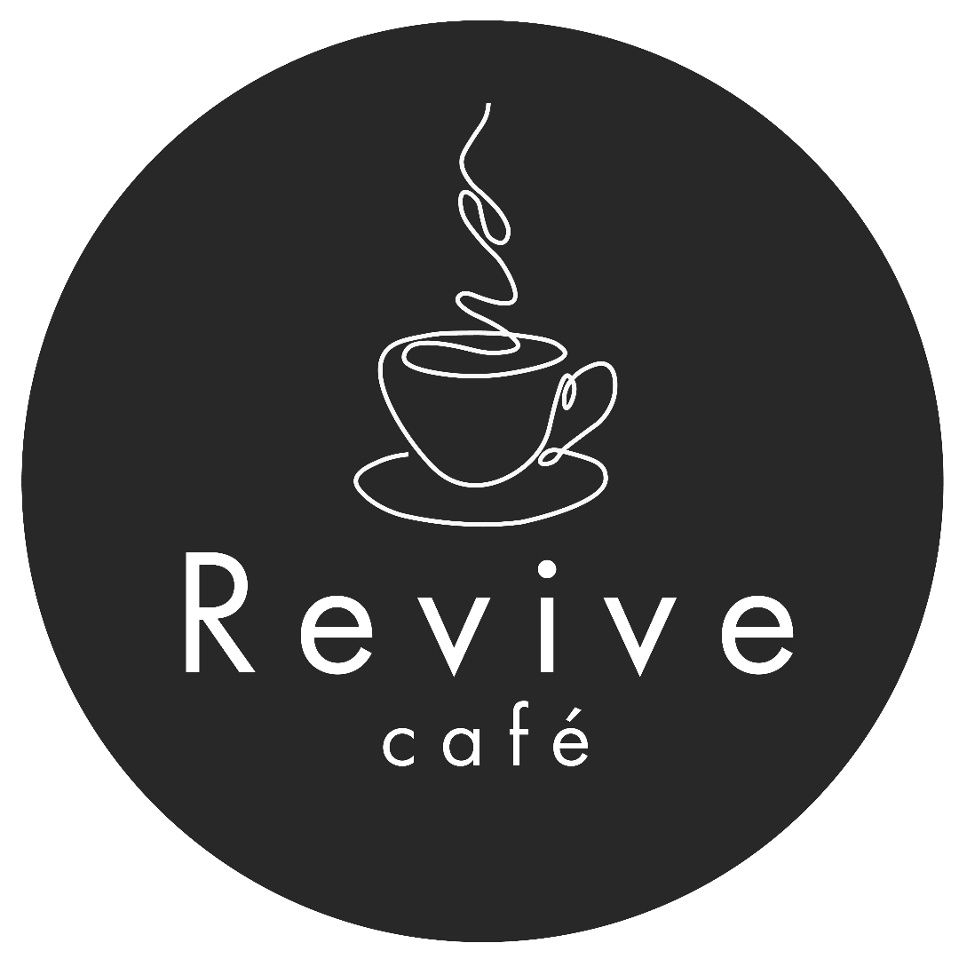

**Tuesday**

**‘Safe Space’ Art Group 12.30-3.00pm**

Meeting weekly for adults to develop friendships, reduce isolation and improve well-being. The group uses art as a creative medium, which is known to help emotional and mental health #**UKSPF.**

**Babysign**

‘Brightasabutton’ helps parents and their little ones to learn communication using simple signs. Free sessions #**UKSPF**: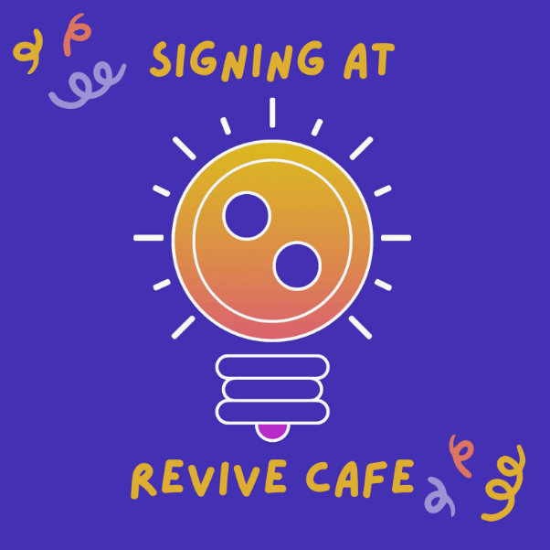

**14th January** for 7 weeks

Babies (pre-walkers) 11:50-12:30

Toddlers (crawlers and walkers) 1-1:40pm

<https://www.brightasabutton.co.uk/bookings>



**Wednesday**

**Refresh@Revive** 

Refresh will be starting **fortnightly on Wednesdays** 11.30 until 1pm

Women’s wellbeing to encourage and support one another.

**Thursday**

**Kintsugi Hope**

From **Thursday 16th January** for 12 weeks. 1.-3.00pm.

This group is a safe and supportive space for people who feel or have felt overwhelmed, providing tools for self-management in a facilitated peer mentoring style setting. It has a flexible series of 12 weeks of content, which include group and individual activities designed to help participants to accept themselves, to understand their value and worth and to grow towards a more resilient and hopeful future.   
For more information contact: [jennylillie04@gmail.com](mailto:jennylillie04@gmail.com)



**Friday**

**Babysign (as above)**

From **Friday 10th January**

Babies (pre-walkers) 10:30am-11:10am

Toddlers (crawlers and walkers) 11:30am-12:10pm

<https://www.brightasabutton.co.uk/bookings>

**What's on:**

**Tuesday**

**‘Safe Space’ Art Group 12.30-3.00pm**

Meeting weekly for adults to develop friendships, reduce isolation and improve well-being. The group uses art as a creative medium, which is known to help emotional and mental health #**UKSPF.**

**Babysign**

‘Brightasabutton’ helps parents and their little ones to learn communication using simple signs. Free sessions #**UKSPF**:

**14th January** for 7 weeks

Babies (pre-walkers) 11:50-12:30

Toddlers (crawlers and walkers) 1-1:40pm

<https://www.brightasabutton.co.uk/bookings>



**Wednesday**

**Refresh@Revive** 

Refresh will be starting **fortnightly on Wednesdays** 11.30 until 1pm

Women’s wellbeing to encourage and support one another.

**Thursday**

**Kintsugi Hope**

From **Thursday 16th January** for 12 weeks. 1.-3.00pm.

This group is a safe and supportive space for people who feel or have felt overwhelmed, providing tools for self-management in a facilitated peer mentoring style setting. It has a flexible series of 12 weeks of content, which include group and individual activities designed to help participants to accept themselves, to understand their value and worth and to grow towards a more resilient and hopeful future.   
For more information contact: [jennylillie04@gmail.com](mailto:jennylillie04@gmail.com)



**Friday**

**Babysign (as above)**

From **Friday 10th January**

Babies (pre-walkers) 10:30am-11:10am

Toddlers (crawlers and walkers) 11:30am-12:10pm

<https://www.brightasabutton.co.uk/bookings>